Once you click on yes it will create the xml file and you can upload that file to unitrace.

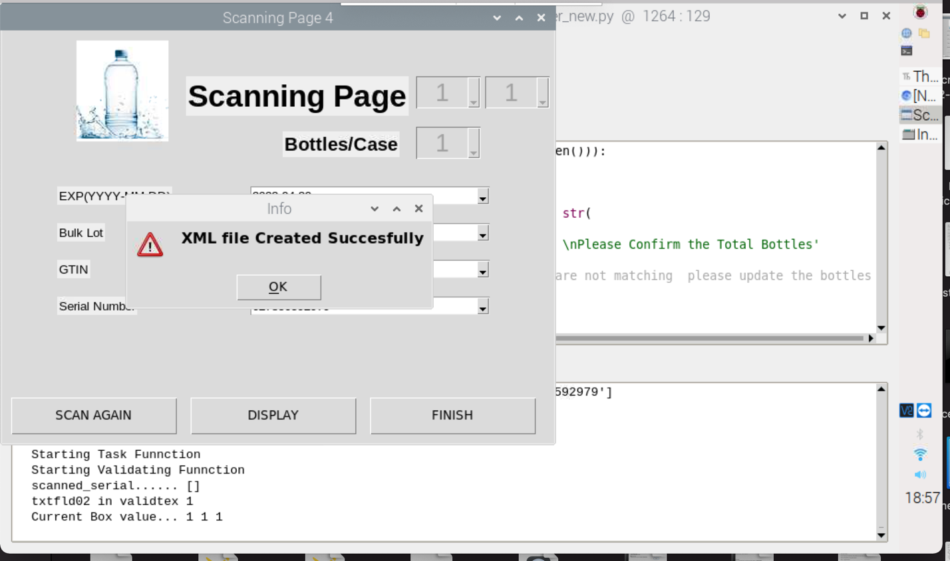

It will ask you do you want to save the details with xml file ,

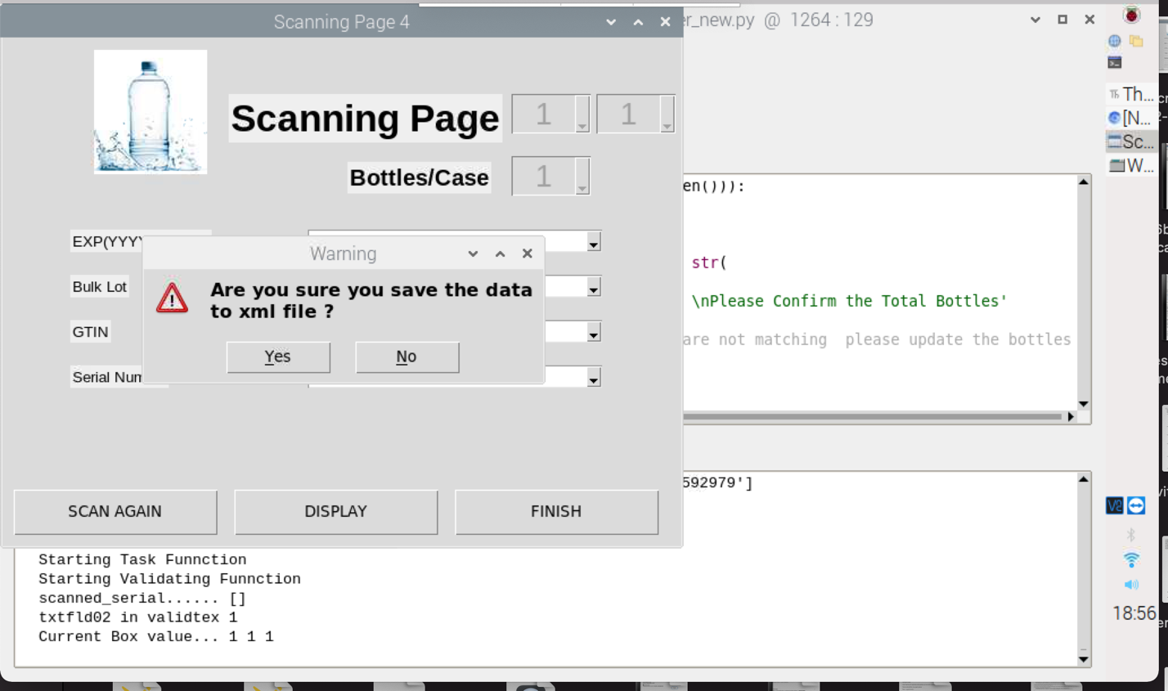

Enter the your password to save the scan bottles details .

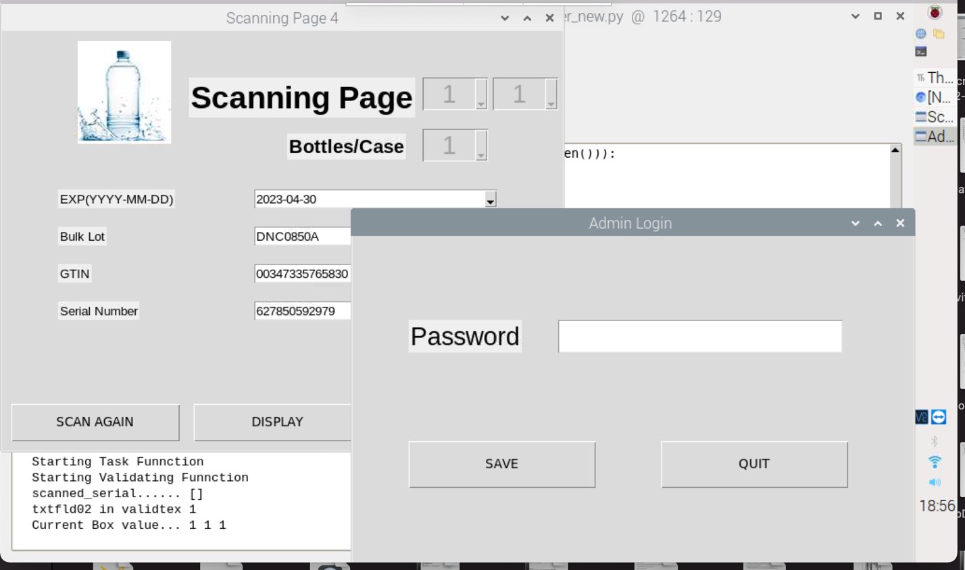

Once you click on yes , you have enter the bottles you have scanned and it will ask you confirm one more time , by enter the total no of bottles .

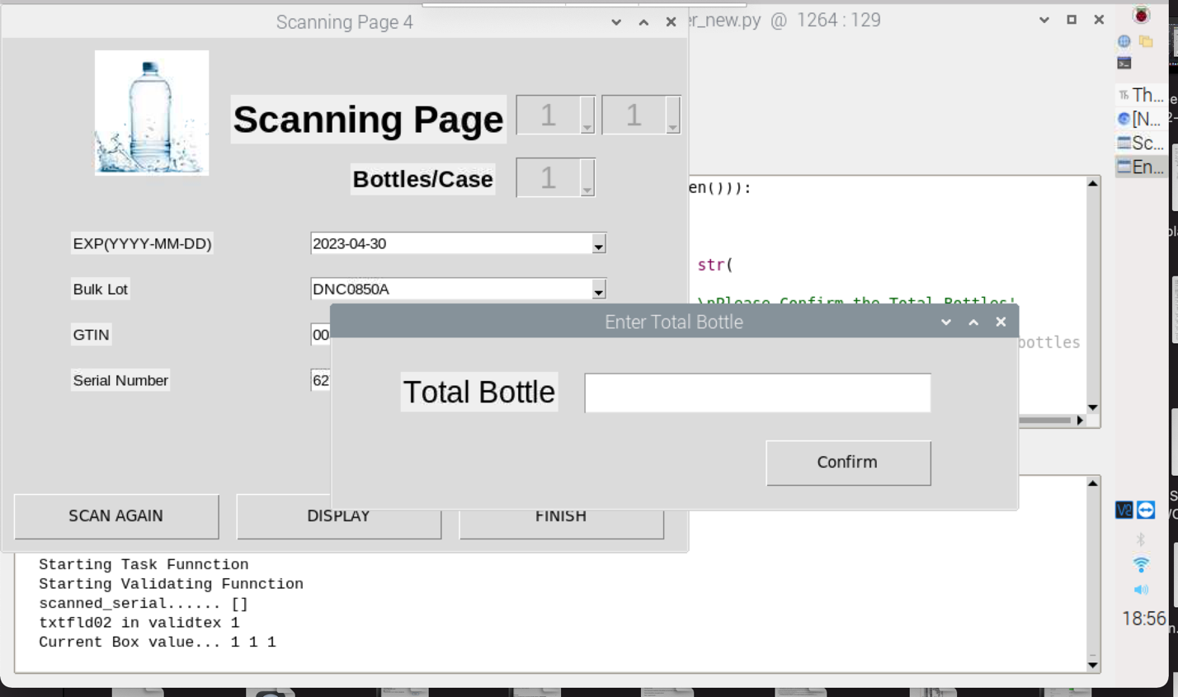

Once the scanning is complete it will ask you confiming the total bottles scanned with total bottle entred . once you click on yes , it will take you another page.,

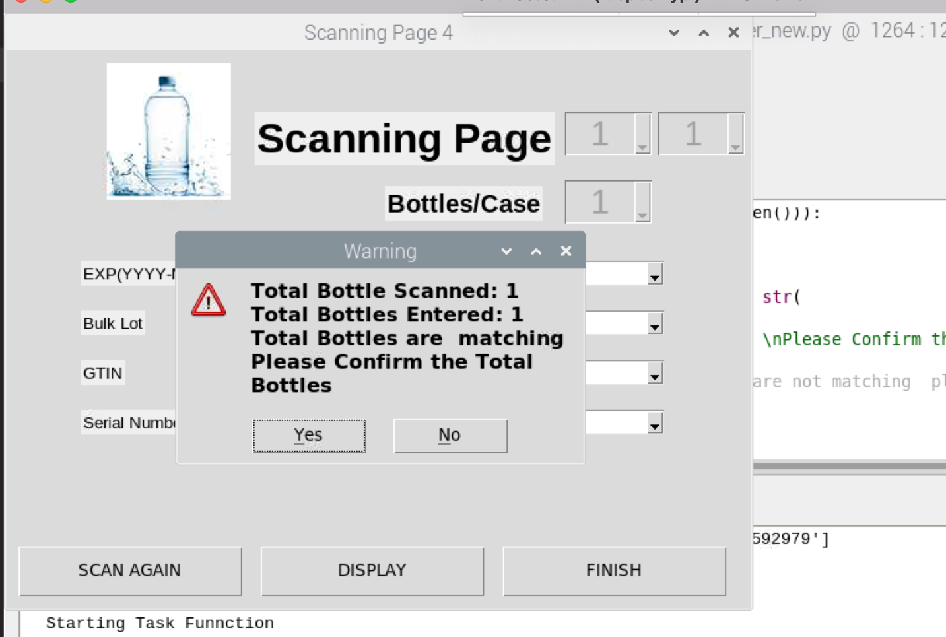

When you Click on Display Button it will show you as bellow ..

It will show you number of Bottles you have scanned , you can delete or finish scanning after verify with production.

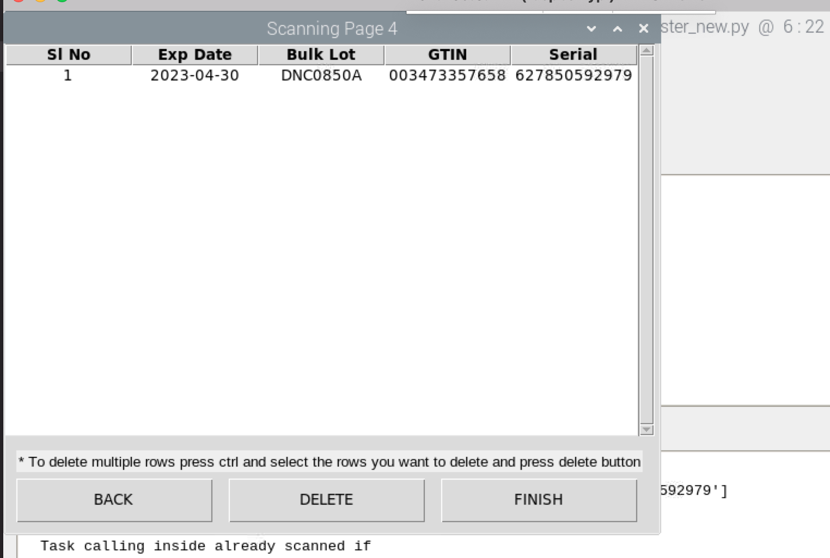

Step 13 once all the information is correct, click on scan & next , it will capture the bottles details ,and shows here ,

On this screen it will show you more information ,

Right side upper top will show you Total bottles which are already scanning now , and total bottles that we have entered on step 4

Bellow that it will show you bottles/case , that count and match with our details that entered in step 5

The display button will display the list of bottles that already scanned.

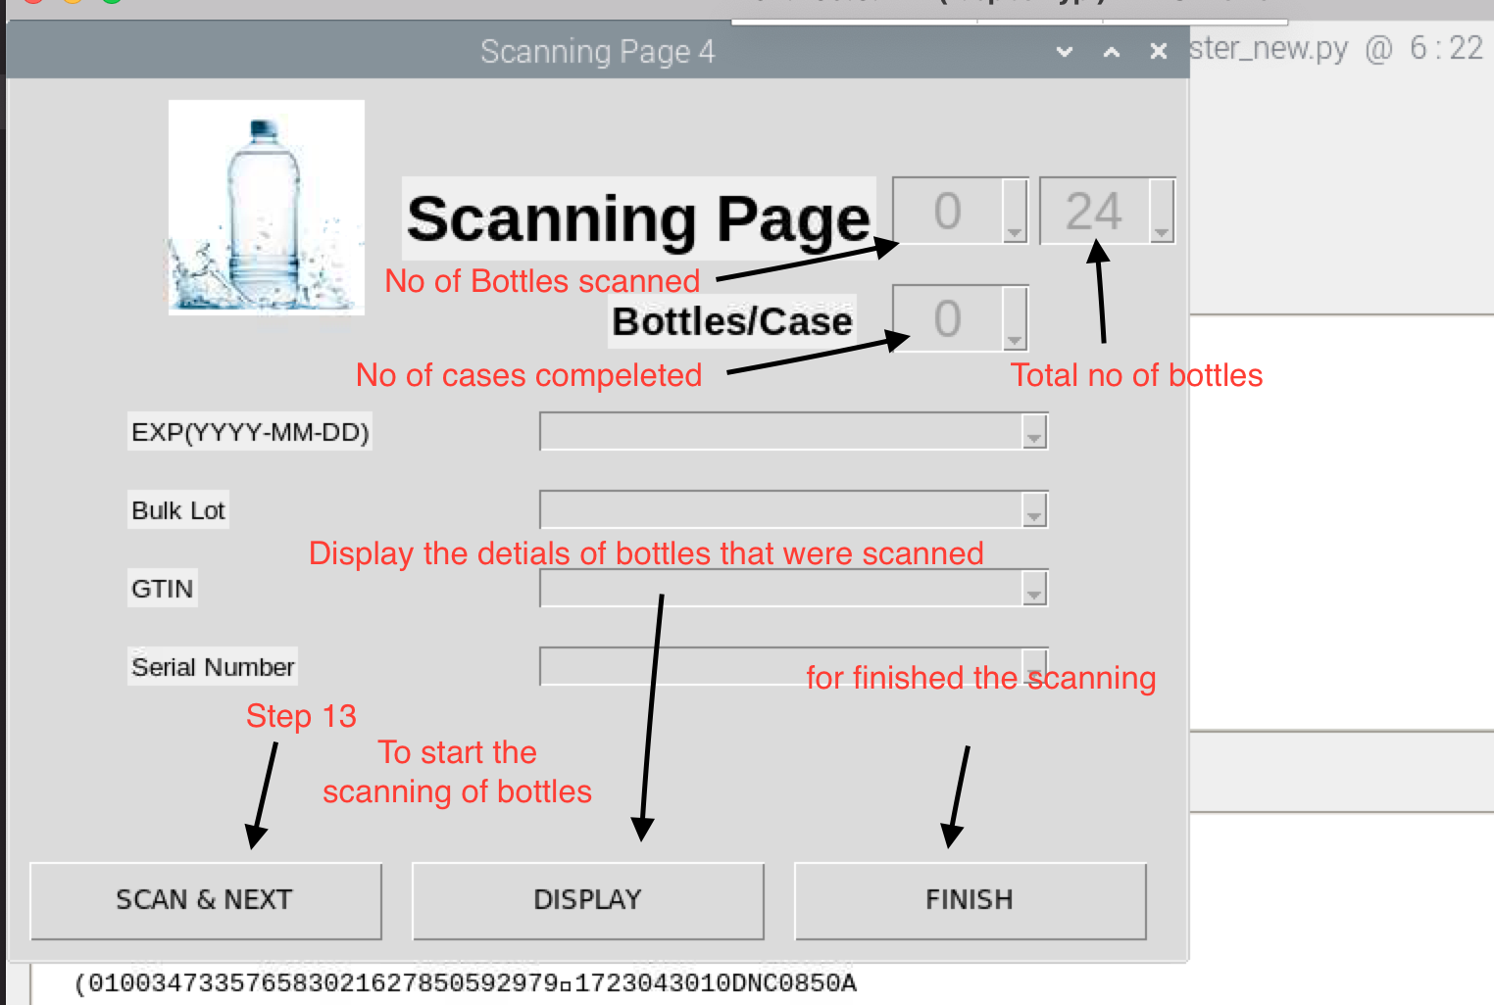

Step 12 verify the details that enterd is correct or not , than click on yes if the information is wrong click on no and it will take you back .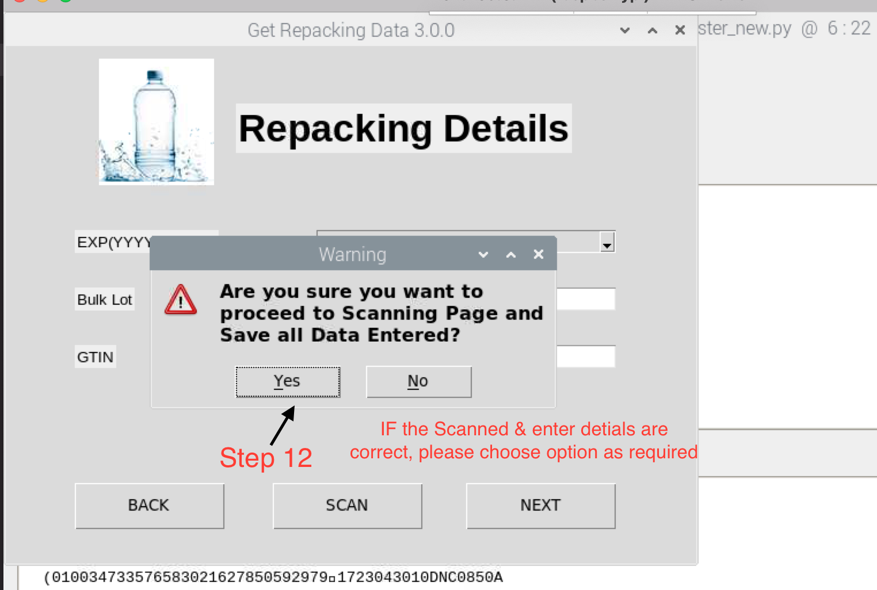

Step 8 Enter the date manually by selecting Date dropdown box

Step 9 Enter the new lot number

Step 10 enter the new GTIN number

Optional:- Scan button if you have new 2D barcode which containing the exp , lot and GTIN,

Step 11 click on next

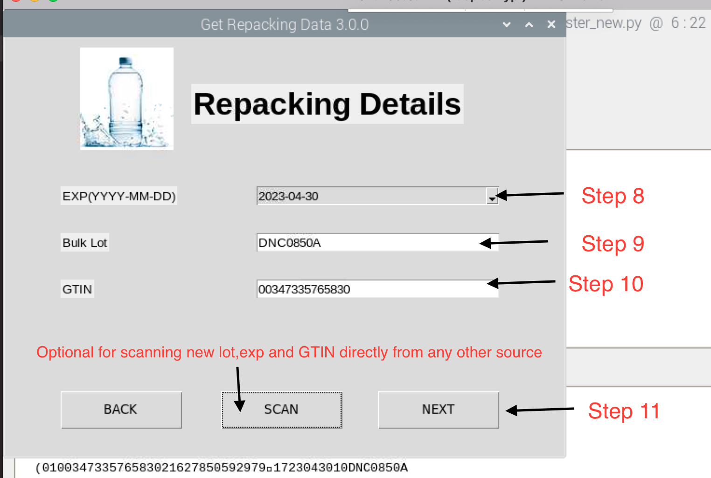

once you pass one bottle, system will show you Expiration date , Lot no and GTIN

Step 4 we have to enter TOTAL BOTTELS

Step 5 we have to enter TOTAL BOTTELS PER CASE

Step 7 Once verify all the details Click on Next button

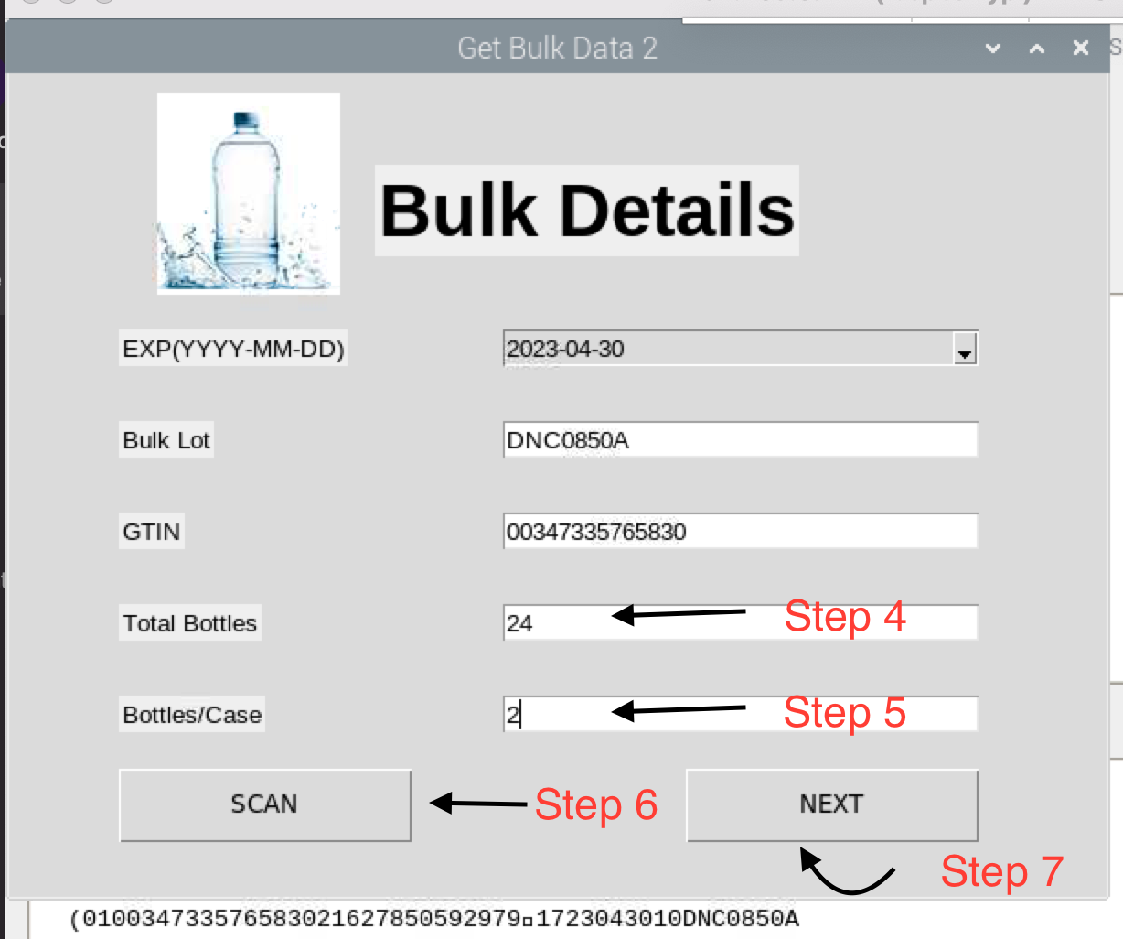



Step 2 enter the bulk Details by passing one bottle.

For that click on SCAN button (Step 2) that will allow the cameras to read the 2D data matrix and get the correct details .

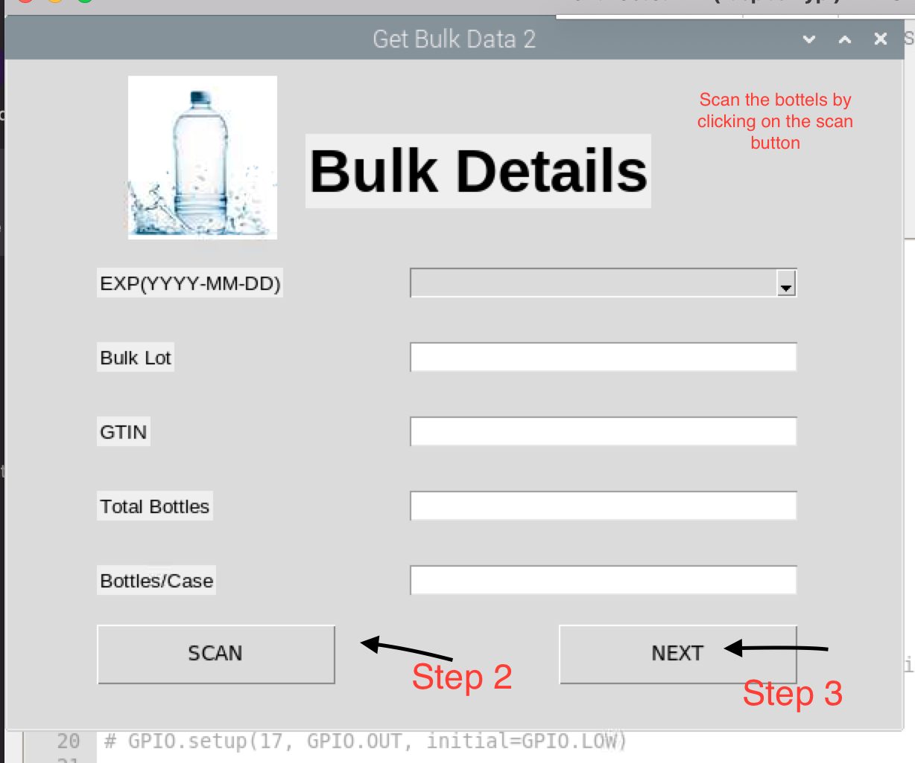

Step 1

Enter Login Details which is provide by Admin